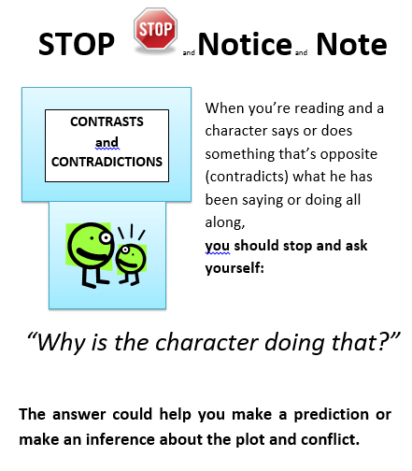 | The text says. . . | Why do I think the character’s doing that? | My prediction/inference about plot and/or conflict is. . .
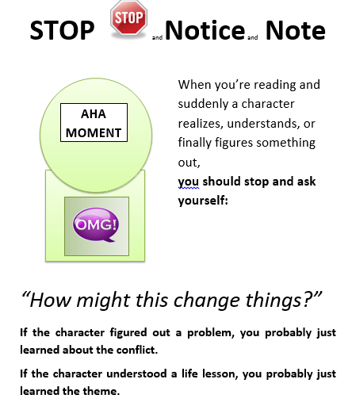 | The text says. . . | How do I think this might change things in the story/for the char.? | A conflict or theme I can infer from this is. . .
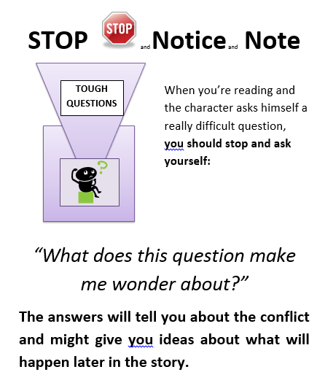 | The text says. . . | What does this question make me wonder about? | A conflict I could infer from this or a prediction I could make from this is. . .
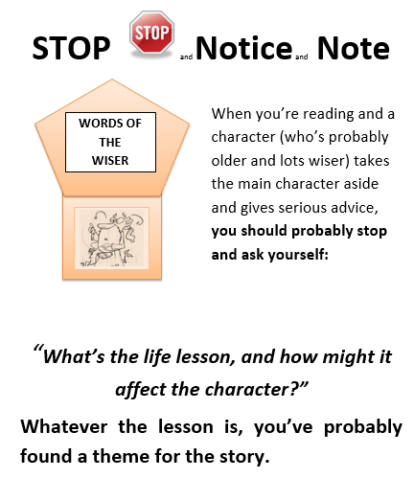 | The text says. . . | What’s the life lesson, and how might it affect the character? | A theme I can infer from this is. . .
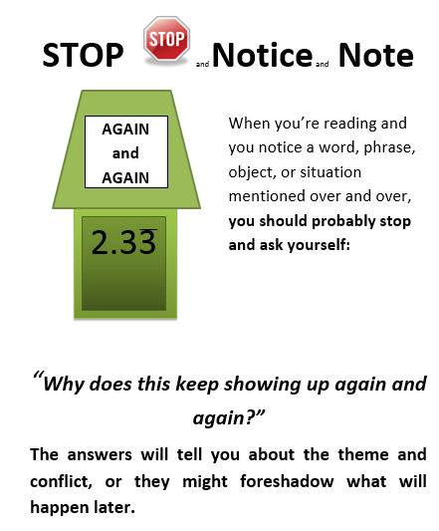 | The text says. . . | Why do I think this keeps showing up again and again? | A theme and/or conflict I can infer or event this might foreshadow is. . .
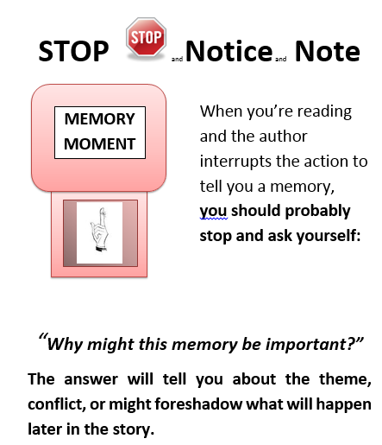 | The text says. . . | Why do I think this memory could be important? | A theme and/or conflict I can infer or event this might foreshadow is. . .

