Name ________________________________ Date ____________________ Block ___________

PROMPT: 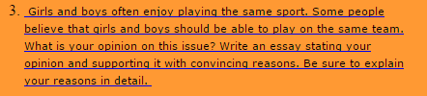

INTRODUCTION: This is your FIRST paragraph (Remember HBT—HOOK, BRIDGE, THESIS)
Hook: A question to get me “hooked” into your paper.

Bridge: This connects your HOOK to your THESIS. It should be 2-3 sentences.

Thesis: This is the focus of the essay—RESPOND TO THE PROMPT. | I agree…….  I disagree……

Supporting Idea 1
Supporting Idea 2
BODY:
Present your supporting idea in a topic sentence. Connect to your thesis. | One reason,  . | Another reason,
Offer an explanation for your supporting idea. What point do you want to make about your supporting idea? | THINK…This is true because | THINK…This is true because
Widen your information  by giving an example. | For example, | For example,
Explain how or why your example is related to your supporting idea.

Restate the supporting idea. What do you want your readers to really know about the supporting idea? | Remember, | Remember,

CONCLUSION: This is your FOURTH paragraph. (Remember RIC—REVISIT, IMPORTANCE, CLINCHER)
Revisit your thesis in a new way. | To sum up,
Importance: Why is this support necessary for your argument?

Clincher: A strong closing that will make the reader agree with you.

